**Assignment 6**

**Draw the DFD to be considered while coding the individual processes or functions.**

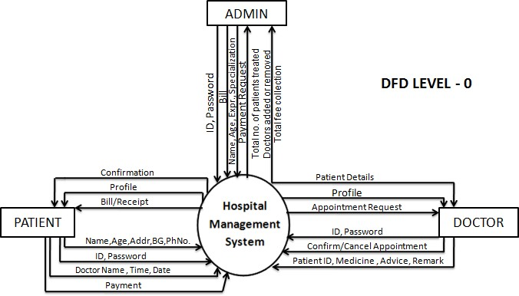

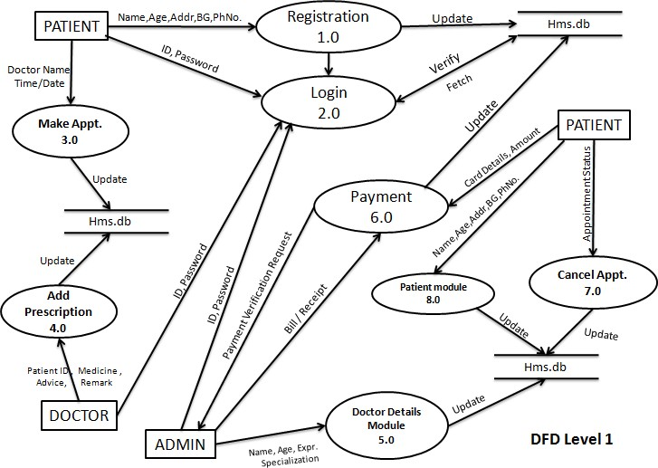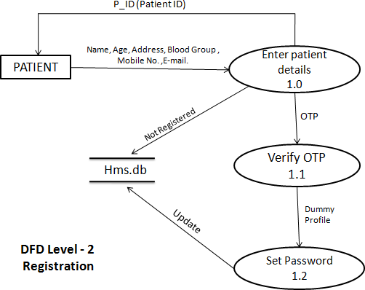

**DFD Level-2 Registration**

**DFD Level-2 Login**

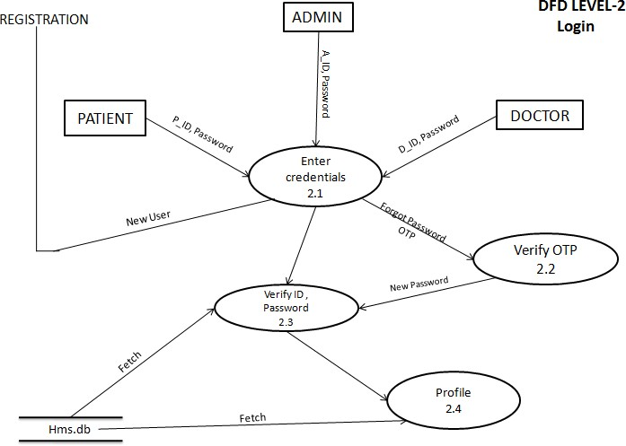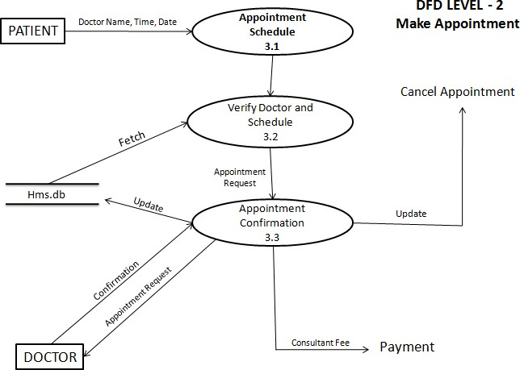

**DFD Level-2 Make Appointment**

**DFD Level-2 Add Prescription**

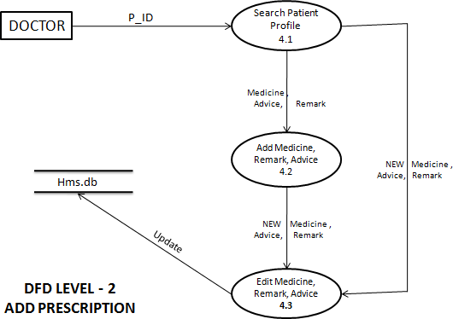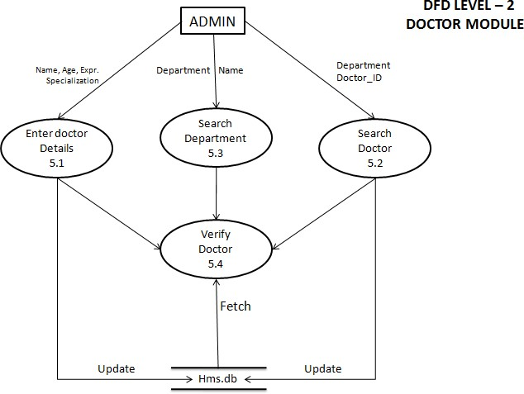

**DFD Level-2 Doctor Module**

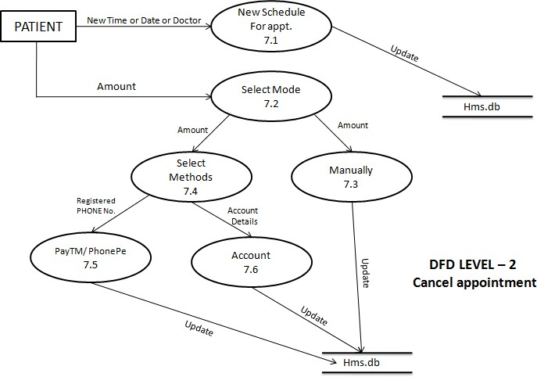

**DFD Level-2 Cancel Appointment**

**DFD Level-2 Patient module**

